WASTE MANAGEMENT & RECYCLING PREDICTION REPORT

MACHINE LEARNING & POWER BI DASHBOARD PROJECT

PROJECT REPORT

BY

MEVINA P.D

DATA ANALYST

UNDER THE GUIDANCE & SUPERVISION OF
Miss Amrutha

Palakkad, Kerala – 678702



CONTENTS

INTRODUCTION

ABSTRACT

OBJECTIVES

METHODOLOGY

DATA ANALYSIS

MODEL DEVELOPMENT & RESULTS

DASHBOARD OVERVIEW

CONCLUSION & FUTURE SCOPE

1. INTRODUCTION

With rapid urbanization and population growth, waste generation has increased significantly, creating serious environmental and public health challenges. Effective waste management and recycling systems are essential to reduce landfill usage, conserve natural resources, and promote sustainable development.

This project focuses on analyzing waste management data and applying machine learning techniques to classify and predict waste types such as recyclable, organic, and non-recyclable waste. The project also includes an interactive Power BI dashboard to visualize waste collection trends, recycling performance, and key indicators that support data-driven decision-making for sustainable waste management.

2. ABSTRACT

This project presents a machine learning–based approach to analyze and predict waste categories in a waste management system. The dataset contains information related to waste type, quantity collected, collection dates, and other relevant attributes.

Exploratory Data Analysis (EDA) is performed to understand waste generation patterns and recycling trends. Multiple machine learning classification models are trained and evaluated to identify the most accurate model. The results are visualized using a Power BI dashboard that provides clear insights into waste distribution, recycling rates, and overall system performance. The project demonstrates how data analytics and machine learning can improve efficiency in waste management and recycling processes.

3. OBJECTIVES

The main objectives of this project are:

To analyze waste management and recycling data using exploratory data analysis

To identify patterns and trends in waste generation and recycling

To preprocess and clean waste-related datasets for machine learning

To build and evaluate multiple machine learning models for waste classification

To identify the best-performing model for waste prediction

To visualize key insights using an interactive Power BI dashboard

4. METHODOLOGY

Step 1: Data Collection

The dataset was collected from a structured CSV source related to waste management. It includes information such as waste type, waste quantity, collection date, and location/category details.

Step 2: Data Preprocessing

Handling missing and inconsistent values

Encoding categorical variables (waste type, category, etc.)

Feature selection and transformation

Splitting the dataset into training and testing sets

Step 3: Exploratory Data Analysis (EDA)

Analysis of total waste collected over time

Distribution of waste by type (recyclable, organic, non-recyclable)

Trend analysis using date-based aggregation

Correlation analysis between waste quantity and categories

Step 4: Model Building

The following machine learning models were implemented and tested:

Logistic Regression

Decision Tree Classifier

Support Vector Machine (SVM)

Random Forest Classifier

Step 5: Model Evaluation

Accuracy score

Confusion matrix

Precision, recall, and F1-score

5. DATA ANALYSIS

Exploratory data analysis revealed important insights into waste generation and recycling behavior. Recyclable waste constituted a significant portion of total waste collected, indicating strong potential for recycling optimization.

Time-based analysis showed fluctuations in waste collection across different periods. Visualizations such as bar charts, line charts, and pie charts were used to represent waste distribution and recycling performance. These insights supported better feature selection and model development.

6. MODEL DEVELOPMENT & RESULTS

Model Performance Comparison
Model | Performance
Logistic Regression | Moderate
Decision Tree | Good
SVM | Good
Random Forest | Best

Best Model: Random Forest Classifier

Achieved the highest accuracy among all tested models

Reduced overfitting through ensemble learning

Important Predictive Features

Waste quantity

Waste category , Collection date patterns

7. DASHBOARD OVERVIEW
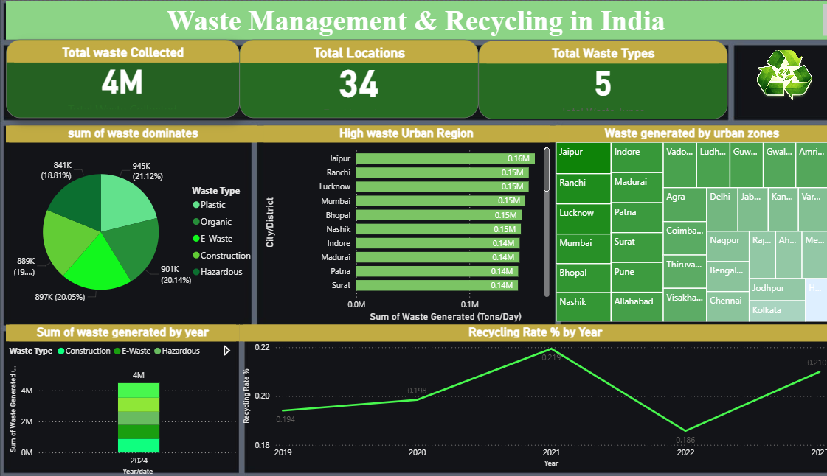
An interactive Power BI dashboard was developed to visualize key waste management metrics. The dashboard includes:
- Total waste collected KPI
- Recyclable waste percentage
- Waste distribution by type
- Time-based waste collection trends
- Category-wise comparison charts
The dashboard enables stakeholders to monitor recycling performance and make informed decisions to improve waste management efficiency.

8. CONCLUSION & FUTURE SCOPE

Conclusion

This project demonstrates the effective application of machine learning and data visualization techniques in waste management and recycling analysis. Through proper data preprocessing, exploratory analysis, and model selection, accurate waste classification was achieved. The Power BI dashboard further enhances understanding by presenting insights in a clear and interactive manner.

Future Scope

Use larger and real-time waste management datasets

Integrate IoT sensor data for live waste monitoring

Apply advanced models such as Gradient Boosting or Deep Learning

Deploy the model as a web or mobile application for smart city solutions

